Helpful hints for home learning…

We appreciate that teaching your own children at home is a very difficult task and there may be a whole range of barriers to home learning. Siblings, working from home yourself, no printer… to name just a few! Hopefully these hints may help.

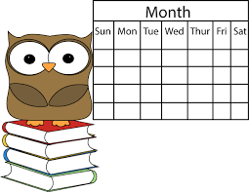
Firstly always remember there is no expectation that the children access all the lessons every day. This would be extremely challenging.

If children need help concentrating or understanding, you could start them off with just one or two lessons a day each, at separate times if you have more than one child in school. Then you can help them focus if necessary.

Perhaps sit down with children at the start of each day and pick which lessons from the weekly home learning grid to do. If you let them choose, this may improve their motivation!

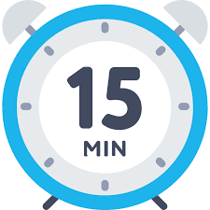
Some of the online lessons have a lot of activities- children don’t have to do them all! Have a quick look through at the start of the lesson and agree which ones to do. Fifteen minutes really concentrating on two activities is so much better than an hour long struggle through all of them! Also perhaps agree before each lesson what they will be able to do afterwards-reward time.

Use mobile phones for Bitesize Daily lessons- the lessons are designed to work best on a mobile phone apparently. Of course iPads, computers, laptops etc work too.

If you have children that can do the lessons on their own, let them use headphones so they’re not as easily distracted.

Use the BBC Bitesize Daily lessons (TV programs) on the Red Button Service or on the iPlayer so that a device isn’t needed. These lessons are a bit more general than the online lessons but they might also help children who struggle to concentrate. The children could watch one of these lessons instead of doing the linked online lesson on a device.
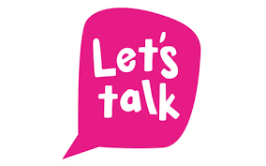
Encourage the children to talk about their lessons with their friends if they can. Children are not used to having to work on their own. In school they are constantly talking about their answers and sharing their ideas.

Children might find the lessons quite hard as they are not in school. Watch the videos a few times or even try the lessons from the year below. All learning is cyclical and what children cover in year 5 for example always starts with a recap of year 4. Having a go at the lessons from the year before might really help so long as you introduce the idea sensitively! Again, everything the children do at home will be a huge bonus in the future.

If children are struggling to concentrate on the Maths or the English particularly, choose an activity from the Home Learning Newsletters instead which the family could do together.
Children love praise when they are learning because it helps them to feel confident. Let them know what they are doing right as much as you can to help them feel positive about the lessons.

The main thing is to make it manageable for you and them and to keep it positive! Obviously all children are different so pick and choose whichever strategies you think may help. Please get in touch with your child’s class teacher if you would like any further support.

