Early Years Foundation Stage: Nursery Phase
Please read the following information
We have put together some information we hope you will find useful in helping us to continue to work together in partnership with you to support your child’s development, learning, health and well-being.
Staggered start and phased adjustment to full sessions
At Mersey Vale we operate a ‘staggered start and adjustment period’ towards your child remaining happily in Nursery for full sessions. By working in partnership with you, we aim to support your child’s individual needs and tailor a program responsive to your child’s stage of development. This will be unique to your child and consider the needs of children of a similar age.
We thank you in advance for your support in making the transition as smooth as possible for all
Experiences to support your child’s development and learning
Practical, play based and fun experiences provided at home and in Nursery will help to enrich your child’s development in many aspects of their learning over time, such as: sharing books at home daily, visiting the local library frequently, playing family games together, solving jigsaws, taking part in messy play activities and creative activities (e.g. arts and crafts), going to the park, drawing, and visiting places, e.g. farm. By engaging in such experiences with you, your child is more likely to develop self-confidence, motivation, perseverance, independence and importantly a positive “I can” attitude towards their own learning and progress.
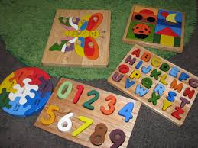
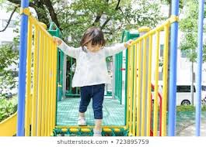
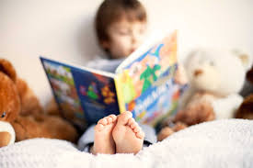
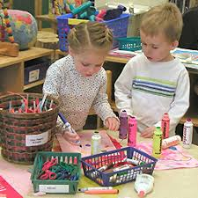
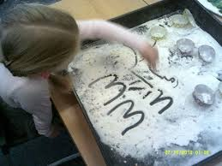

Celebrating efforts and achievements
Each child is given a ‘Home School Communication Book’. This is for you to add comments about things your child is doing and learning at home. Staff will also add comments re: special moments your child would like to celebrate with you at home. Please return these on Mondays/ child’s first session of the week. Each child also has a special patch/ area on the wall inside the classroom where observations of what he/she has been doing are placed alongside photos and other notes. The children are very proud of these areas. Please come and take a look and feel free to add your own comments to it. Complete a ‘wow’ moment slip and stick it on Children’s efforts are displayed throughout the classroom. This helps to build their self-confidence, self-esteem and motivation for learning. Come and take a look around! We also share information via Class Dojo and the class page on school website.
Learning Experiences
Children are encouraged to take part in a variety of indoor and outdoor activities to support their learning and development in all seven areas of the Early Years Curriculum: Communication and Language; Personal, Social and Emotional; Physical; Literacy; Maths; Understanding the World and Expressive Arts and Design. The nursery routine enables all children to engage in a balance of child-initiated and adult-led learning experiences delivered in a supportive, structured and stimulating learning environment.
Clothing and footwear
To enable all children to actively participate fully, please ensure that your child is dressed in clothing which they are able to manage themselves e.g. when dressing/ undressing and accessing the toilet. Tight fitting and restrictive clothing (e.g. tight fitting trousers/ jeans) can cause difficulty for children who are learning to manage their own self-care and become more independent. Also, the children take part in a range of active experiences both indoors and outdoors to support their physical development and freedom of movement is really important for children to develop gross motor skills. Leggings, jogging bottoms, t-shirt/ jumper please. We can get rather messy too so please don’t wear your best clothes for Nursery. Please ensure that a full set of clothes plus spare items remains on their peg in bag (named) at all times.
Wellington boots/ fashion boots can be brought to Nursery (in a bag, named) to be put on for outdoor activities but must not be worn as their footwear for the session/ day as it restricts movement and comfortable sitting. Footwear children can put on and take off themselves e.g. good fitting, sturdy trainers/ pumps with velcro straps are preferable, no lace up shoes please.
A warm and waterproof coat must be brought every day whatever the weather as we access our outdoor learning areas in all weathers to support our development in all areas of the curriculum.
If your child has pierced ears, please ensure they wear stud earrings, not looped/ dangling style for safety reasons. Other fashion jewellery type items should remain at home.
Nursery uniform (Royal blue sweatshirt/ cardigan) can be purchased from the school office/ ordered for you.
Supporting self-care and independence skills at home
For some children it can take time to manage their personal hygiene (toilet training). However, making time for it and supporting the process at home is required to enable your child to make progress and become more independent in the setting. Taking them to the toilet on arrival to nursery can help to develop the routine and ease anxieties.
Please encourage your child to develop skills e.g. dressing/ undressing, putting shoes and socks on/ off, helping to tidy away toys and join you in daily tasks, e.g. setting the table. This will build their self-confidence, personal skills and enable them to take an active part in nursery life.
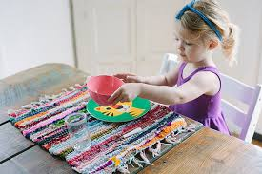

Sharing books at home
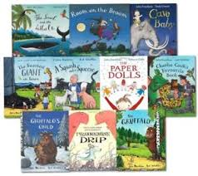
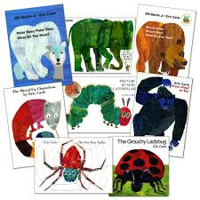
Please spend time daily sharing a book with your child. Library books from Nursery are chosen and brought home every week. Joining the local library is another way of enjoying the pleasure of reading together. Please return books weekly so that your child can choose another book. It is likely that your child will choose the same book for a few weeks. Repetition of a familiar story is really important for language development and early reading skills.
Snacks
Children receive a healthy snack including: fruit and a drink every session they attend. A contribution of £1 per week towards this would be much appreciated. Please pay via ParentPay.
Please ensure that your child has breakfast/ lunch at home, not on arrival to the Nursery session.
Lunch time
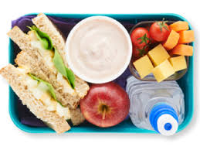
Children who stay for lunch are required to bring a healthy lunch to Nursery (on specific days). This should include savoury items your child likes to eat plus fruit, yoghurt and a healthy drink.
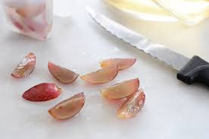
If you include grapes, please ensure that you cut them correctly (in advance) for the safety of your child (sliced into quarters, lengthways).
Mobile phones
To ensure the safety of all, please do not use a mobile phone in school. They must not be visible within the classroom setting. We would be grateful if other family members could be informed of this e.g. if/when a relative brings/ collects children from school.
Finally…
As always, if you have any questions or you require further information, please do not hesitate to speak to a member of staff.
Thank you for your continued support.
Nursery Staff

